**DAILY ONLINE ACTIVITIES SUMMARY**

|  |  |  |  |  |  |  |  |  |
| --- | --- | --- | --- | --- | --- | --- | --- | --- |
| **Date:** | **06-06-2020** | | | | | **Name:** | **Deril Quadras** | |
| **Sem & Sec** | **8 A** | | | | | **USN:** | **4AL16CS031** | |
| **Online Test Summary** | | | | | | | | |
| **Subject** | | **IOT** | | | | | | |
| **Max. Marks** | | **30** | | **Score** | | | **30** | |
| **Certification Course Summary** | | | | | | | | |
| **Course** | **Machine Learning Building Blocks: Services and Terminology.** | | | | | | | |
| **Certificate Provider** | | | **AWS** | | **Duration** | | | **40 mins** |
| **Coding Challenges** | | | | | | | | |
| **Problem Statement:**   1. **Write a program in C to rotate an array by N positions.** | | | | | | | | |
| **Status: Solved** | | | | | | | | |
| **Uploaded the report in Github** | | | | | **Yes** | | | |
| **If yes Repository name** | | | | | **Derilquadras/online_c_coding_repository** | | | |
| **Uploaded the report in slack** | | | | | **Yes** | | | |

Online Test Details: (Attach the snapshot and briefly write the report for the same)



Certification Course Details: (Attach the snapshot and briefly write the report for the same)

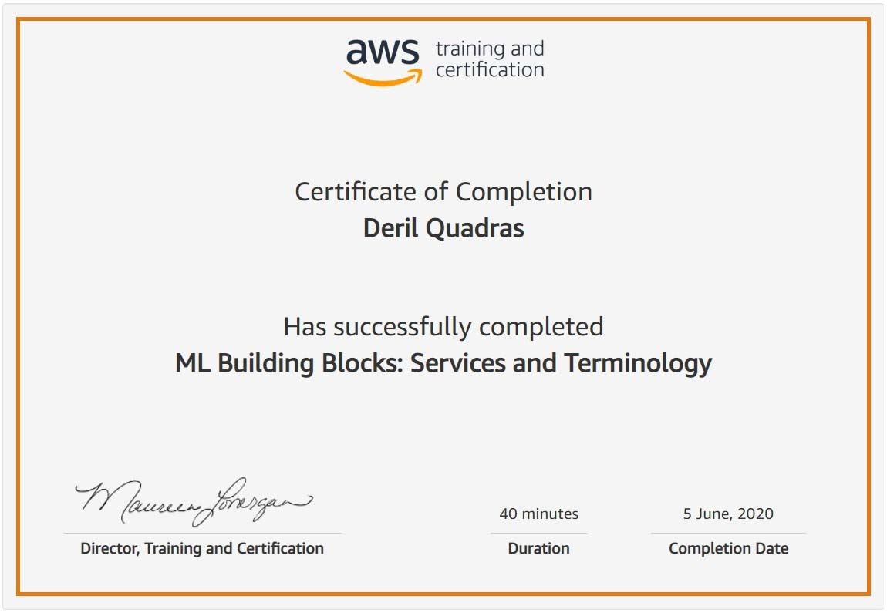

Coding Challenges Details: (Attach the snapshot and briefly write the report for the same)

**PROGRAM 1 .**

**// Write a program in C to rotate an array by N positions.**

**#include <stdio.h>**

**void shiftArr1Pos(int *arr1, int arrSize)**

**{**

**int i, temp;**

**temp = arr1[0];**

**for(i = 0; i < arrSize-1; i++)**

**{**

**arr1[i] = arr1[i+1];**

**}**

**arr1[i] = temp;**

**}**

**void arr1Rotate(int *arr1, int arrSize, int rotFrom)**

**{**

**int i;**

**for(i = 0; i < rotFrom; i++)**

**{**

**shiftArr1Pos(arr1, arrSize);**

**}**

**return;**

**}**

**int main()**

**{**

**int arr1[] = {0,3,6,9,12,14,18,20,22,25,27};**

**int ctr = sizeof(arr1)/sizeof(arr1[0]);**

**int i;**

**//---------- print original array ------------------------**

**printf("The given array is : ");**

**for(i = 0; i < ctr; i++)**

**{**

**printf("%d ", arr1[i]);**

**}**

**printf("\n");**

**//---------- print the values from 4th position ------------------------**

**printf("From 4th position the values of the array are : ");**

**for(i = 4; i < ctr; i++)**

**{**

**printf("%d ", arr1[i]);**

**}**

**printf("\n");**

**//---------- print the values before 4th position ------------------------**

**printf("Before 4th position the values of the array are : ");**

**for(i = 0; i < 4; i++)**

**{**

**printf("%d ", arr1[i]);**

**}**

**printf("\n");**

**//------------ after rotating the array --------------------**

**arr1Rotate(arr1, ctr, 4);**

**printf("\nAfter rotating from 4th position the array is: \n");**

**for(i = 0; i<ctr; i++)**

**{**

**printf("%d ", arr1[i]);**

**}**

**return 0;**

**}**